5/7/2026
Professor Spangler
CYBIT298-480
Final Report: ACME Tutoring Center
Group 5: Cameron Edenburn, Patryk Wirth, Zachary Czaplicki, Esteban J. Garduno

The focus of the ACME Tutoring Center is to provide a technology solution in a secure, reliable, and scalable network infrastructure that supports tutoring operations across the organization daily. The design of the Acme Tutor Center includes several essential cybersecurity and networking components. This includes security information and event management, LDAP and Active Directory, web authentication, and firewall configuration. It also includes the planning of the network topology, cost analysis, and vulnerability testing. These components work together to protect students, staff, and organizational data by enabling authorized users to securely access necessary resources. The final design of the Acme Tutoring Center connects multiple critical systems, including a firewall, Security Information and Event Management (SIEM), Web Authentication, and a Domain Controller with Active Directory, to provide a robust enterprise environment for the tutoring center. This solution supports confidentiality, integrity, and availability of data for students and staff who need it.
Significant research was also dedicated to Security Information and Event Management (SIEM) systems. Multiple platforms were evaluated, including Graylog, the ELK stack (Elasticsearch, Logstash, and Kibana), Wazuh, and Splunk. Splunk was initially considered due to its widespread use in industry environments; however, limitations of the free version led to reconsideration. Ultimately, Security Onion was selected due to it being “a free tool for anyone looking to reinforce their network security tool pack without spending a fortune. Its blend of network and host visibility, coupled with powerful analysis tools, makes it a go-to solution for threat hunting, monitoring, and log management” (Seget, 2025, pp. 9-10). Security Onion is widly regareded to be a standard integration of Elasticsearch, Logstash, and Kibana, making it a strong centralized logging and monitoring solution. Additional research included syslog server implementation, log forwarding techniques, and compatibility differences between Linux and Windows systems. Windows logging required further investigation due to its lack of native syslog support, leading to exploration of tools such as NXLog, Sysmon, and Winlogbeat. Network design research also played a key role. Topics included demilitarized zones (DMZs), virtual private networks (VPNs), next-generation firewalls (NGFWs), and Layer 3 switching. This research influenced decisions such as moving the web authentication server into the DMZ, eliminating the need for a dedicated VPN server, and implementing a Layer 3 switch to simplify communication between sites. Budgeting research was also performed to understand the real-world costs of infrastructure, including hardware, software licenses, HVAC requirements, and power consumption.
The implementation process began with the preparation of virtual machines and system environments. All required systems were installed in advance to ensure a smooth transition into configuration. The SIEM implementation followed a structured pipeline:
Syslog server → Security Onion → Log shipping agents → Security rules → Event testing. Initial configuration involved setting up the Security Onion environment, updating the system, and reviewing configuration files. A syslog server was implemented as a centralized log collection point, allowing Linux systems to forward logs efficiently. A major part of the configuration process involved enabling communication between systems. Firewall rules were configured to allow traffic between devices, the syslog server, and the SIEM. Troubleshooting was required when logs initially failed to reach the SIEM due to closed ports and misconfigurations. For Linux systems, log forwarding was configured successfully through syslog. For Windows systems, multiple approaches were tested. Winlogbeat and Sysmon were implemented for Windows 10 and Windows 11 systems, while older versions were required for Windows 7 compatibility. After challenges with syslog integration, Winlogbeat was ultimately used to forward Windows logs directly to Logstash. Additional configuration improvements included adjusting log outputs to display hostnames instead of loopback addresses, configuring Kibana dashboards for log visualization, and creating alerting rules. Final implementation steps involved transferring all virtual machines and configurations to a centralized system, resolving IP conflicts, and ensuring full communication between all components of the network.
The project required strong collaboration across all team members. Responsibilities were divided into specialized roles, including SIEM implementation, LDAP configuration, firewall setup, and web authentication. Communication and organization were maintained through a Discord server, which included channels for documentation, configurations, and troubleshooting. This allowed for efficient sharing of information and resources. The team collaboratively designed the network topology using draw.io, combining elements from each member’s design into a final version. Adjustments were made collectively, including reducing the number of devices to better match a small tutoring center and improving wireless coverage. Team members also worked together during the budgeting phase to calculate infrastructure costs and identify unnecessary components. Later stages of the project involved consolidating all configurations onto a single system, requiring coordination to ensure compatibility between all virtual machines and services. Peer review was also conducted, particularly during the hardening phase, where vulnerabilities in each system were analyzed and addressed collectively.
This project provided valuable hands-on experience in multiple areas of networking and cybersecurity. A deeper understanding of SIEM systems was developed, including log aggregation, parsing, and analysis using Security Onion and Kibana. Practical experience was gained in configuring log forwarding tools such as Syslog, NXLog, Winlogbeat, and Sysmon across both Linux and Windows environments. Knowledge of network design significantly improved, particularly in areas such as DMZ implementation, VPN configuration, Layer 3 switching, and firewall rule management. The project also highlighted the importance of system hardening and vulnerability analysis, reinforcing the need for secure configurations in enterprise environments. Additionally, experience was gained in virtualization, system integration, and troubleshooting complex multi-system environments. The budgeting phase provided insight into the financial considerations of IT infrastructure, which is often overlooked in technical projects. Collaboration skills were also strengthened through consistent communication, documentation, and shared problem-solving.
One of the biggest challenges encountered was configuring communication between the syslog server and the SIEM. Logs initially failed to parse correctly despite multiple configuration attempts, requiring extensive troubleshooting and analysis of the entire logging pipeline. At first the logs were going to go to the syslog then to Logstash to then be parsed into Kibana, but the windows VM used did not want to send logs to the syslog server. Instead of spending more time on troubleshooting this, eventually only Linux logs were parsed into the syslog server, and all the Windows logs just went straight to Logstash instead of going through syslog first. Another major challenge involved integrating Windows systems into the SIEM. Unlike Linux systems, Windows does not natively support syslog, which requires additional tools and significant trial and error. Compatibility issues with older systems such as Windows 7 further complicated the process, requiring specific versions of Sysmon and Winlogbeat. Although Nxlog was considered, it did not have as much compatibility and documentation as Winlogbeat. According to George Kobar, the product marketing director at Elastic, claims that “Elasticsearch is a distributed, RESTful search and analytics engine capable of addressing a growing number of use cases. As the heart of the free and open ELK or Elastic Stack, it securely stores your data for lightning-fast search, fine-tuned relevancy, and powerful analytics that scales with ease” (Seget, 2025, p. 1). Winlogbeat seemed to have more use cases and documentation, therefore making it easier to install on Windows machines, especially those that were outdated, like the Windows 7 virtual machine. Nxlog did not have as much documentation or backwards compatibllity for older operating systems.
Elastic Transferring virtual machines and configurations between systems also presented challenges due to VM limitations and file transfer restrictions. Security Onion ISO used was outdated, considering an ISO version that was more modern could have made the entire project much easier. Especially in the context of packages and quality of life features being enabled and updated. Not having the ability to even copy/paste into the VM made it inconvenient, but the workaround that was found is just using SSH to drop files that are already configured into the VM environment. Manual configuration adjustments were sometimes required to ensure compatibility. Additionally, managing firewall rules and ensuring proper communication between all components of the network requires careful planning and continuous troubleshooting.
For future iterations of the project, several improvements could be implemented. Standardizing configurations earlier in the project would reduce troubleshooting time later. Establishing a clear baseline for IP addressing, firewall rules, and system configurations would improve consistency across all components. Using a centralized environment earlier in the process would also improve efficiency. Instead of transferring configurations at the end, building and testing within a shared system from the beginning would simplify integration. The consideration of using a different SIEM also could have been a good course of actions since Security Onion experience was not lacking, but Wazuh experience was not present, so learning a new program could have been an even better learning experience. That automation could be introduced, particularly in log forwarding and system configuration, to reduce manual setup and potential errors. Improved documentation of troubleshooting steps and configurations would also benefit future implementations by providing a clear reference for resolving issues. The labeling for each system could have been executed better. Giving each machine a unique name to distinguish what alert the machine was coming from instead of just an IP address. Finally, additional time could be dedicated to advanced security features such as automated alerting, threat detection rules, and deeper vulnerability testing to further enhance the overall infrastructure.
Although there were some configuration errors, in the end all machines were able to talk to Logstash and were parsed into Kibana. Since this was the goal in the beginning, it was definitely met and this project gave confidence to the entire team, because the project turned out to be better than expected.
The LDAP and Active Directory portion of the project focused on building a centralized identity and access management environment for the tutoring center infrastructure. The goal of this implementation was to provide a secure and organized method for managing user accounts, authentication, permissions, and policy enforcement across the network environment. Active Directory was selected because it is widely used in enterprise environments and allows organizations to centrally manage users, devices, security policies, and authentication services.
The project group implemented a Windows Server 2022 domain controller and configured a new Active Directory domain named “acmetutor.local.” This domain served as the central authentication source for the tutoring center environment. DNS and DHCP services were also configured alongside the domain controller to support internal network communication and centralized device management. Research performed during this process showed that Active Directory environments heavily depend on proper DNS configuration because Active Directory Domain Services uses DNS to help clients locate domain controllers and allow domain controllers to communicate with each other (Microsoft, 2025a). This made DNS validation an important part of the domain controller deployment because unreliable DNS could prevent users, workstations, and connected services from properly reaching the domain.
To improve organization and scalability, Organizational Units (OUs) were created to separate users, workstations, servers, groups, and service accounts into structured categories. Additional sub-OUs were created for departments and roles such as faculty, students, human resources, and administrators. This structure allows the tutoring center to manage users and devices more efficiently while also preparing the environment for future expansion. Separating users and systems into organized containers also allows policies and permissions to be applied more consistently throughout the environment.
User accounts were created to simulate realistic tutoring center operations. Administrative accounts, faculty accounts, student accounts, and HR accounts were all configured with password policies that required users to change their passwords upon first login. This approach helps reduce the risk of insecure default credentials remaining active within the environment. Service accounts were also created for SIEM and web authentication integrations for secure login and SIEM log forwarding. These accounts followed least privilege principles by separating automated service authentication from standard user accounts.
Security groups and file sharing groups were also implemented as part of the LDAP infrastructure. These groups allowed permissions to be assigned based on job role rather than individual user accounts. Microsoft explains that security groups are used to collect accounts into manageable units and assign permissions to shared resources, which made them a practical choice for managing access in the tutoring center environment (Microsoft, 2025c). This provides a more scalable environment because permissions can follow a user’s role through group membership changes, avoiding tedious individual permission changes for each account or modifying the OU structure. Research and implementation throughout the project demonstrated that group-based access control provides greater flexibility for managing shared folders, applications, printers, VPN access, and future system integrations.
The project group also implemented baseline Group Policy Objects to establish minimum security standards across the tutoring center domain. Policies were applied to strengthen password management, Windows Defender Firewall settings, and auditing configurations for logon activity, user management, and account monitoring. These policies helped improve visibility and accountability across the environment while also supporting SIEM integration and centralized logging efforts. Baseline GPOs allowed the environment to maintain consistent security standards across systems connected to the domain.
Although baseline policies were successfully implemented, one important lesson learned throughout the project was that identity management environments are never truly “finished.” While the baseline GPO structure successfully met the security requirements for the project, additional time could have been used to create more granular Group Policy Objects for specific security groups and departments. Microsoft explains that Group Policy can use security filtering to refine which users and computers receive specific policy settings, which supports the idea that policies can be targeted more precisely than only applying broad domain-wide or OU-wide baselines (Microsoft, 2025b). For the tutoring center, this would allow separate restrictions for students, faculty, administrators, and HR users without restructuring the entire OU design. Separate policies for students, faculty, administrators, and HR users would allow tighter restrictions and more customized access control throughout the environment. Future improvements could also include implementing read-only domain controllers for remote locations and creating more advanced file-sharing environments with tested read-only and read-write permissions between departments.
The LDAP infrastructure also worked closely with other areas of the project. Integration planning was performed with the web authentication environment so that domain accounts could eventually authenticate through the tutoring center web portal using LDAP-based authentication. Service accounts and directory synchronization were prepared to support this functionality. Collaboration also took place with the firewall portion of the project to help secure the domain controller prior to vulnerability testing. Firewall rules were configured to prevent unauthorized external systems from reaching sensitive services on the domain controller while still allowing required internal communication between approved systems and services.
One challenge encountered near the final stages of the project involved instability with the web authentication environment. During vulnerability testing and final integration stages, the authentication web server experienced connectivity and web application issues that prevented full browser-based testing from being completed. Despite this issue, LDAP integration planning, service account preparation, firewall coordination, and authentication configuration were still largely completed and demonstrated the intended design of centralized authentication for the tutoring center environment.
Overall, the LDAP and Active Directory implementation provided the tutoring center with a centralized and scalable identity management environment capable of supporting authentication, policy enforcement, user organization, and future growth. The project also demonstrated how directory services integrate with other cybersecurity technologies such as firewalls, SIEM platforms, and web authentication systems in a real-world enterprise environment. Through the implementation process, the project group gained practical experience with enterprise identity management, security policy design, system integration, and infrastructure planning that can be applied to future cybersecurity and systems administration roles.
For web authentication research, this role focused on how a secure login system could be used to protect a tutoring center's web resources. The research included Identity providers, Single sign-on, LDAP and Active Directory integration, Reverse proxy authentication, Firewall access controls, and Security monitoring through a SIEM. Authentik was researched because it could act as the identity provider for the tutoring center and provide single sign-on for the protected web application. NIST guidelines were also reviewed to support the importance of identity and access management, access controls, and strong authentication methods. NIST research helped decide how the web authentication system would be implemented and how it can connect to the rest of the tutoring center's infrastructure.
Web authentication has an important role for this project as it controls how users would securely access tutoring centers' protected web resources. The web authentication role also helps support the client's need to control access and user accountability for protecting student and staff information. NIST explains that identity and access management helps ensure that the correct people and devices have the correct access to the correct resources at the correct time (National Institute of Standards and Technology, 2025). This all connects directly to the project because the authentication system is designed to prevent open access and make sure that users had to sign in before reaching the protected web page.
For the web authentication system, Authentik was used as the identity provider. Authentic is an open-source identity provider and single sign-on platform that can be used to manage user authentication for application services. Authentic describes itself as an “IdP (Identity Provider) and SSO (Single Sign On) platform” that supports secure and flexible authentication (authentik, n.d.-c). This made Authentik a great option for the tutoring center because it allowed the protected webpage to rely on central login systems instead of having a basic standalone login page. For the project's design, a user would go to the protected web page and then be redirected to the Authentik sign-in after signing in with their credentials it will return them to the web application after a successful log in client-facing login process.
Implementation of the web authentication server started with installing Authentik servers on an Ubuntu server VM using Docker Compose. Docker was used because it allowed Authentik services to run in containers, making the environment easier to start, stop, manage, and troubleshoot. The Authentik setup included a main server service, worker service, databases of PostgreSQL and Redis needed for the platform to run. After the containers were running, the Authentik admin interface was able to be accessed and configured for the web authentication server. The admin interface included admin settings, creating, testing users, checking the login page working with the authentication flow. The goal was to make sure the users could authenticate through Authentik before reaching the protected webpage.
Also, through the implementation process, Authentik connects the web server through a proxy-based authentication infrastructure. The purpose of this was to place a connection in which authentication is in front of the web application instead of allowing authentication. Authentik's forward authentication documentation explains that forward auth allows a reverse proxy to handle the web traffic while Authentik checks whether the user is authenticated and authorized (authentik, n.d.-a). This was an essential part for the tutoring center because the web server needed to depend on Authentik to decide whether a user should be allowed to log in. For the client's environment this means the web server is not just publicly open. It is also protected by an authentication login process to verify its users first.
The implementation process for web authentication also included connection to the Lightweight Directory Access Protocol in which, for this project, Active Directory was used. This would allow the tutoring center to manage users and groups from one central location, so creating separate accounts for every service in Authentic LDAP source documentation. It explains that LDAP sources allow Authentic to connect with an external directory service and import users and groups (authentik, n.d.-b). For the Tutor Center this means Authentik could be designed to use LDAP as a source for students, staff, tutors, or administrator accounts. This would make account management easier for the client as users could be added, removed, or updated in one directory and those changes would be reflected in the authentication system.
Web authentication server is also connected with the firewall. As the firewall controlled what traffic could reach the web server, the firewall would need to allow the correct traffic for users to reach a login portal and protected web application while blocking all unnecessary or unsafe access. This helped support the principle of least privilege by only allowing traffic needed for service function. It also allowed the web server to be accessed on the external and internal network. The web server also connected to the SIEM because it would log authentication events that are important for security monitoring. The SIEM collected and reviewed logs from the different systems in order to detect any suspicious activity. For the project Authentik provided useful security logs such as successful login, failed login attempts, account issues, possible unauthorized access. These would be sent to the syslog server and SIEM to monitor any activity and respond to possible threats. This is an important connection as authentication is not only about allowing users to sign in. It also creates records to help see who accessed the system and when.
There are several lessons that came from the web authentication role for this project. One of the lessons is that web authentication is more than just creating a login page. A complete authentication server includes components such as an identity provider, user accounts, authentication flows, proxy settings, redirections, firewall access rules, LDAP integration and, logging. Using Authentik, the project shows how an identity provider controls access to a protected web application and provides a more secure login process for users. Authentik helped demonstrate how a single sign-on can give users a central place to authenticate instead of requiring separate logins for each application. This is important for a Tutor Center environment as staff, tutors, students, and administrators may all need different levels of access to specific resources. Another important lesson is understanding how web authentication connects to the rest of the roles for the project. The web server could not be a stand-alone system as it depended on other parts of the project to work properly. LDAP and Active Directory were needed to provide users and groups. The firewall would control traffic that could reach the web server and authentic web page. SIEM would collect the logs for authentication activity. This really shows that the web authentication is part of a larger security design not just a separate entity. A challenge that the project faced was the understanding of how Authentik components work together. The Authentik admin interface includes applications, providers, flows, stages, sources, and outposts. Each has its specific role in the authentication process. At first these were confusing because they sound similar but control different parts of the system. All these different parts were required for the project and for how Authentik works as an identity provider and how it can connect a protected application and how users are redirected to the login portal. Another challenge was connecting Authentik with the LDAP and Active Directory server. The Active Directory server was able to be pinged from inside the authentication server and it did not allow syncing from inside the Authentik admin interface. Information such as base DN, bind DN, and bind CN were able to be found but there was trouble with synchronization between the Authentik web authentication server and the Active Directory server.
As for the next iteration of this project the first improvement would be to fully integrate the web authentication and LDAP server first as this will allow Authentik to use decentralized accounts or the client environment. This would help with testing as with it working properly; other parts of the project would be easier to troubleshoot and complete. An improvement to the web authentication role would be to add multi-factor authentication for staff and administrator accounts. As CISA explains, multi-factor authentication is a layered approach that requires users to provide more than one credential before being granted access, which would help reduce the risk of unauthorized access if a password were stolen or guessed (Cybersecurity and Infrastructure Security Agency, n.d.). This would create extra steps for the overall project, but it would be an improvement in its security as there would be multiple ways to prove authorized access. Another change for the next iteration of this project would be to improve the web page design. The project was designed for a tutoring center. The login page should be customized with the organization's name, logo, and a clean layout that is easy for users to follow. This overall would make the login page more professional and easier to recognize. Also, with Authentik you could create a branded login portal to ensure users are signing in to the correct service.
When it comes to the world of Cybersecurity there are many major roles in protecting people’s information or any important data. A key example of protection is the firewall. Firewall helps monitor network traffic that is coming into systems and ensure that any network traffic is malicious and isn’t allowed to connect to the network. As well as ensure that if any traffic is heading outbound isn’t allowed to be seen from unknown sources. For the server, the role of firewall was to ensure that the server was protected from outside sources and ensure that internal systems and networks can communicate to outside systems. The responsibility that was allowed for the firewall is making sure all ports were being scanned and that only ports that were needed for the project and for other members roles were used and needed.
Throughout the whole project there were a lot of ups and downs such as setting up the firewall in general to ensure that everyone can communicate to outside sources. Also setting up the DMZ to catch any traffic that is coming in and going out and scanning all networks to see if they have any malicious malware or anything. As well be able to set up rules for other members for other roles such as web authentication, SIEM, and LDAP. Each role has security policies and that if any traffic they can read is caught, each role can do their own role respectfully. As for the struggles that were faced during this project was ensuring that all ends of the team are being secure and that everything can communicate to one another. One struggle that was faced was adding too many rules which didn’t allow the firewall to perform the tasks that were assigned properly. Overall, the project allowed a lot of insight into the real world of cybersecurity where the real-world experience on what it takes to build a successful server and see how collaborative with everyone is key to ensure everything is done.
For the role of firewall, tasks were performed and researched as well in this group assignment. With the research found in the beginning weeks, all UDP and TCP ports needed to be unblocked due to the fact that new firewalls block everything right away when installed into a new system. As well as make sure to identify all LAN and WAN that are untrusted and trusted and make sure that everything that is needed is allowed and what is not blocked internally and externally. Establish firewall zones, and IPS to ensure that everything is flowing through the firewall to prevent any unwanted intrusion from getting in. Also investigating the SIEM so other roles can achieve their tasks and complete them. Looking into the DMZ where must enable the DMZ Web Server to the internet. Later in the week rules were created in the firewall to establish a beginning of the firewall development. Looked into advanced settings of firewalls which were needed for remote site locations where a VPN connection would have to be established, so they are able to communicate with the main site. When it came later in the research for the firewall, we started looking into web authentication and having to ensure that all outside sources were being scanned and pinged into the main network. As well as ensuring that outside sources are being authenticated with system software to ensure that if anyone is using malicious malware, they would not be allowed into the server room. Later in the research that was performed for this project was ensured that all migrations of roles into the main system have their capabilities met in the main system to ensure that they can run at their fullest capability and ensure that any rules that needed to be added were added to ensure that they are allowed into the system and also the server. Research that was performed used in many sources but key sources that were used in Paloalto, STIG Viewer and as well as NIST. With each source proving their very own research and explanation for firewall rules and explanation for each rule made and used. With NIST providing in detail explanation of how each step of how a firewall works and how the overview of the firewall plays a role. “Many of these exploits can be detected by specialized application firewalls called web application firewalls that reside in front of the web server.” Web application provides the base detail of how the firewall works and as of how it is the key detail of protecting servers from malicious attacks. Which explains in detail about how outside attackers are unable to intrude the systems servers and how without its attackers would be able to exploit it.
Installed a firewall that is agreed upon with all group mates and as well made sure it can run in the current windows systems. Rules were created to prevent any malicious connection from happening. As well create rules where users can communicate with each other via internally and that any external communication would have to be seen and to have judged if it is a trusted external source and if not, it would not allow communication with any internal sources. As users were blocked, any untrusted internet connections would be blocked as well. As pfsense was installed and configured to proper terms for the firewall as well made sure that any packets were being traced and can communicate to the network. For the web authentication server, had to ensure that the web server itself can connect to outside sources as well and that it could also ping outside sources to ensure that everything is safe. Assure that any outside sources that are not authenticated are not allowed to ping back to the web server and not allowed to access. During the migration phase was being performed to ensure that Web Auth was able to run smoothly and That is was able to connect to outside sources, and more rules had to be implemented into the DMZ, where if any pings were coming from the inside, the server had to run through the DMZ to ensure that they were safe. As for other members' roles, rules had to be implemented so that they would work with the main server properly. The vulnerability testing made sure to scan the system for any vulnerabilities, and with the scan showing some vulnerabilities were able to see where to fix the server to ensure all measures of safety are locked down. Also, fix anything that needs to be fixed.
As tasks that were performed in the beginning weeks of this group assignment were to make sure that everyone can communicate with each other. As in the beginning of the weeks, have established roles for one another and as well made sure that all roles are using the same virtual machines as well as it would be better to transfer over once every role comes together. Later in the week communication between group mates to make sure that if any needed ports were required for them to do their tasks as well to make sure that they are as well able to communicate with anyone else in the group to make sure that no one is able to do their role. As communicate with one another about tasks, ensure understanding the basics of selected roles to establish a strong base. When it came to working with all members of the server, had to ensure that everyone’s role was able to work successfully in their own systems and that they were able to connect to the main system once implemented all the roles together.
Overall, this project not only did it allow gain hands-on experience for the role of firewall but also showed what it takes for the role to work properly. The research portion of the project to make sure that a system needs certain rules is incredibly informative about how certain networks require certain rules to ensure that if any organizations require multiple connections or communications between users to allow base communication. Also, look into rules that would affect the firewall and how it would provide more security not just for the firewall but also for the users where they would be protected as well. With the help of sources such as Paloalto explaining the best practices for firewall users, “That's where security profiles come in. They extend firewall rules by attaching deeper inspection capabilities. Examples include intrusion prevention, anti-malware, URL filtering, and DNS protection.” With Paloalto providing information on firewalls and how to ensure that the best features are enabled for server safety but as well be to explain how each step that is being explained and taken play into the safety of users from malicious attacks. Ensuring that each rule that is made can perform a specific role. One another source that was used was STIG viewer in which this source/site can help firewall reveal any openings of where attackers could attack and make users vulnerable to attacks. Also be able to explain how each vulnerability is key by showing the danger level of each one. With showing which should be taken care of right away.
With the project coming to an end, the experience that was gained truly allowed to expand my knowledge on firewalls and how they are vital key in the success of systems and serves and how if they don’t need many rules to ensure safety and that if too many rules are implemented they will scramble the systems rules and on what to protect and what ports to keep open and as well to make sure that all if done correctly.

\
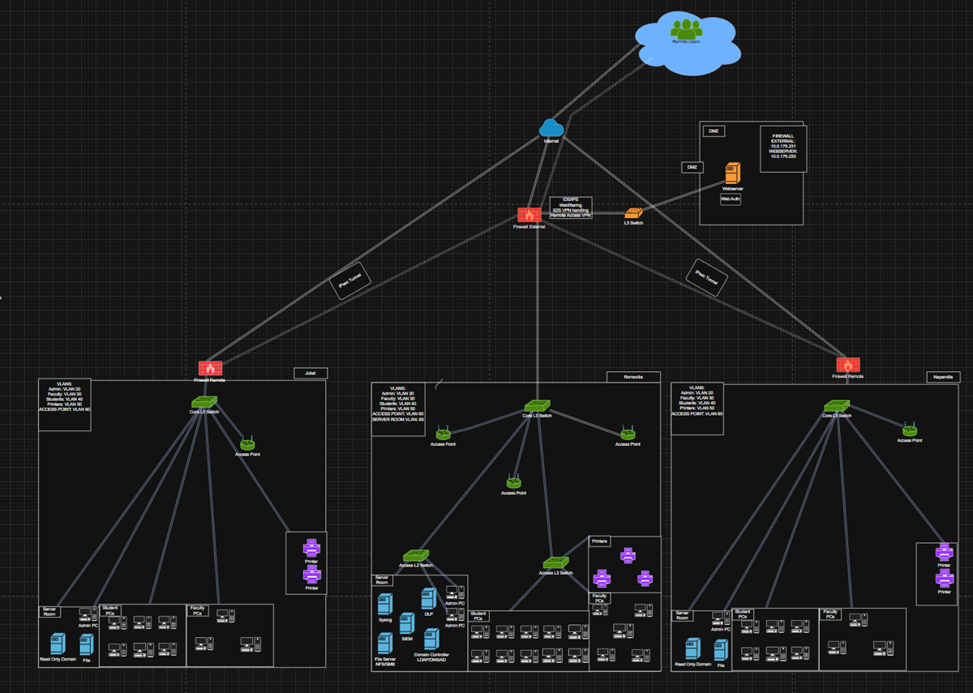
Network Topology

ACME Tutoring Center Cost Analysis

Cost Summary
Location | One-Time Purchases | Recurring ISP | Recurring Subscriptions
Romeoville Main Site | $111,028.15 | $150/month | $234/month
Naperville Remote Site #1 | $43,313.72 | $150/month | $88/month
Joliet Remote Site #2 | $43,313.72 | $150/month | $88/month
Total | $197,655.59 | $450/month | $410/month
Overall Recurring Cost | N/A | N/A | $860/month total recurring

Romeoville Main Site - Endpoints, Network, Power, Rack, and Services
Category | Item | Qty | Unit Cost | Total / Monthly Cost | Description / Product Source
Printing | Departmental laser printers | 2 | $969.99 each | $1,939.98 | Kyocera ECOSYS PA4000cx A4 Color Printer  Source: Kyocera ECOSYS PA4000cx A4 Color Printer
Printing | Centralized multi-function printer | 1 | Not listed | $1,699.00 | Lexmark CX635adwe multifunction color printer
Subscriptions | Domain registration and SSL / HTTPS certificate | 1 plan | $20/month | $20/month | Cloudflare Small Business Plan  Source: Cloudflare Small Business Plan
Subscriptions | Cloud backup | 10 TB | $6 per TB/month | $60/month; $720/year | Backblaze B2 cloud backup  Source: Backblaze B2
Workstations | Desktop PCs for 5 faculty, 10 student, and 2 admin users | 17 | $1,054.99 each | $17,934.83 | HP ProDesk 4 G1i Desktop Computer with Intel Core Ultra 5, 16 GB RAM, 512 GB NVMe SSD  Source: HP ProDesk 4 G1i Desktop Computer
Licensing | Microsoft Windows Server 2022 user CALs | 17 | $59.99 each | $1,019.83 | User CAL licensing listed in original cost analysis  Source: Microsoft Windows Server 2022 - 1 User CAL
Subscriptions | Microsoft 365 Business Premium | 7 | $22/month each | $154/month | Monthly productivity and security subscription  Source: Microsoft 365 Business Premium
Workstations | Keyboard and mouse sets | 17 | $22.99 each | $390.83 | HP Wired Desktop 320MK Mouse and Keyboard  Source: HP Wired Desktop 320MK Mouse and Keyboard
Workstations | Monitors | 17 | $109.99 each | $1,869.83 | ViewSonic VA2456a-MHD 1080p IPS 24-inch monitor  Source: ViewSonic VA2456a-MHD 24-inch Monitor
Workstations | Webcams | 7 | $69.99 each | $489.93 | Logitech webcam  Source: Logitech C920e Webcam
Network | Layer 3 switch | 1 | Not listed | $3,242.99 | HPE Networking 2930F 48G PoE+ 4SFP+ managed rack-mountable switch. L3, PoE+, rack-mountable.  Source: HPE Networking 2930F 48G PoE+ 4SFP+ Switch
Network | Layer 2 switches | 2 | $599.99 each | $1,200.00 | HPE Networking Instant On 1930 24G Class4 PoE 4SFP/SFP+ 370W managed rack-mountable switches  Source: HPE Networking Instant On 1930 24G PoE Switch
Security | Mid-range next-generation firewall | 1 | Not listed | $4,596.99 | Fortinet FortiGate 100F with 1 year FortiCare Premium Support and 1 year FortiGuard Enterprise  Source: Fortinet FortiGate 100F
Internet | ISP service | 1 | $150/month + fees | $150/month; $129.95 install; $27.95 equipment | Comcast Business Internet Gigabit Extra 1.25 Gbps. Quote used JJC Joliet campus address.  Source: Comcast Business Internet Gigabit Extra
Cabling | Cat6 cabling | 64 drops | $7.99 each | $511.36 | C2G 5ft Cat6 snagless UTP Ethernet cables. Rounded up from 58 drops to 64 for spares.  Source: C2G 5ft Cat6 Ethernet Cable
Power | UPS | 1 | Not listed | $2,572.99 | Eaton Tripp Lite SmartOnline 3000VA 2700W 120V double-conversion UPS with 7 outlets and network card  Source: Eaton Tripp Lite SmartOnline 3000VA UPS
Rack | Main site server rack | 1 | Not listed | $2,063.99 | APC NetShelter SV 42U rack, 19-inch standard, 800 mm width, 1200 mm depth, locking side panels, cable management, airflow optimized  Source: APC NetShelter SV 42U Server Rack
Wireless | Wireless access points | 3 | $858.99 each | $2,576.97 | HPE Networking AP-635 Wi-Fi 6E access points with ZigBee and Bluetooth  Source: HPE Networking AP-635 Wi-Fi 6E Access Point
Licensing | Windows Server 2022 physical server licenses | 7 | $1,493.99 each | $10,457.93 | Microsoft Windows Server Datacenter Edition - 16 cores

Romeoville Main Site - Server Hardware
Category | Item | Qty | Unit Cost | Total / Monthly Cost | Description / Product Source
Server | Domain controller server | 1 | Not listed | $8,359.00 | HPE ProLiant DL360 Gen11. 1U rack server, compute-optimized for AD and infrastructure services, RAID 1.  Source: HPE ProLiant DL360 Gen11 Rack Server
Server | Web server | 1 | Not listed | $8,359.00 | HPE ProLiant DL360 Gen11. 1U rack server, compute-optimized for web and authentication services, RAID 1.  Source: HPE ProLiant DL360 Gen11 Rack Server
Server | File server | 1 | Not listed | $4,649.99 | HPE ProLiant DL385 Gen11 8LFF CTO Server. 2U chassis, 8 x 3.5-inch drive bays, storage-focused workload, RAID 10.  Source: HPE ProLiant DL385 Gen11 8LFF CTO Server
Server | Syslog server | 1 | Not listed | $8,359.00 | HPE ProLiant DL360 Gen11. 1U rack server, compute-optimized for logging services, RAID 1.  Source: HPE ProLiant DL360 Gen11 Rack Server
Server | SIEM server | 1 | Not listed | $3,398.99 | HPE ProLiant DL345 Gen11 8LFF CTO Server. 2U server, 8 x 3.5-inch bays, large log retention capacity, RAID 10.  Source: HPE ProLiant DL345 Gen11 8LFF CTO Server
Server | DLP server | 1 | Not listed | $8,359.00 | HPE ProLiant DL360 Gen11. 1U rack server, compute-optimized for infrastructure services, RAID 1.  Source: HPE ProLiant DL360 Gen11 Rack Server

Romeoville Main Site - Server Storage
Category | Item | Qty | Unit Cost | Total / Monthly Cost | Description / Product Source
Storage | Domain controller storage | 2 x 480 GB SSD | $1,139.99 each | $2,279.98 | 480 GB usable RAID storage. HPE SATA 6Gb/s hot-swappable 2.5-inch SFF SSDs.  Source: HPE 480 GB SATA SSD
Storage | SIEM storage | 4 x 8 TB HDD | $629.99 each | $2,519.96 | 16 TB usable RAID storage. Axiom 8 TB Enterprise SAS 12Gb/s, 3.5-inch LFF, 7200 RPM, hot-swappable HDDs.  Source: Axiom 8 TB Enterprise SAS HDD
Storage | Syslog storage | 2 x 4 TB SSD | $1,139.99 each | $2,279.98 | 4 TB usable RAID storage. Samsung PM893 3.84 TB SATA III 2.5-inch enterprise SSDs.  Source: Samsung PM893 3.84 TB SATA SSD
Storage | File server storage | 6 x 12 TB HDD | $832.99 each | $5,177.94 | 36 TB usable RAID storage. Axiom 12 TB SAS 7200 RPM LFF 512e hot-swap HDDs.  Source: Axiom 12 TB SAS Hot-Swap HDD
Storage | DLP storage | 2 x 4 TB SSD | $1,139.99 each | $2,279.98 | 4 TB usable RAID storage. Samsung PM893 3.84 TB SATA III 2.5-inch enterprise SSDs.  Source: Samsung PM893 3.84 TB SATA SSD
Storage | Web server storage | 2 x 480 GB SSD | $1,139.99 each | $2,279.98 | 480 GB usable RAID storage. HPE SATA 6Gb/s hot-swappable 2.5-inch SFF SSDs.  Source: HPE 480 GB SATA SSD

Naperville Remote Site #1
Category | Item | Qty | Unit Cost | Total / Monthly Cost | Description / Product Source
Printing | Departmental laser printers | 2 | $969.99 each | $1,939.98 | Kyocera ECOSYS PA4000cx A4 Color Printer  Source: Kyocera ECOSYS PA4000cx A4 Color Printer
Workstations | Desktop PCs for 3 faculty, 6 student, and 1 admin users | 10 | $1,054.99 each | $10,549.90 | HP ProDesk 4 G1i Desktop Computer with Intel Core Ultra 5, 16 GB RAM, 512 GB NVMe SSD  Source: HP ProDesk 4 G1i Desktop Computer
Licensing | Microsoft Windows Server 2022 user CALs | 10 | $59.99 each | $599.90 | User CAL licensing listed in original cost analysis  Source: Microsoft Windows Server 2022 - 1 User CAL
Subscriptions | Microsoft 365 Business Premium | 4 | $22/month each | $88/month | Monthly productivity and security subscription  Source: Microsoft 365 Business Premium
Workstations | Keyboard and mouse sets | 10 | $22.99 each | $229.90 | HP Wired Desktop 320MK Mouse and Keyboard  Source: HP Wired Desktop 320MK Mouse and Keyboard
Workstations | Monitors | 10 | $109.99 each | $1,099.90 | ViewSonic VA2456a-MHD 1080p IPS 24-inch monitor  Source: ViewSonic VA2456a-MHD 24-inch Monitor
Workstations | Webcams | 4 | $69.99 each | $279.96 | Logitech webcam  Source: Logitech C920e Webcam
Network | Layer 3 switch | 1 | Not listed | $3,242.99 | HPE Networking 2930F 48G PoE+ 4SFP+ managed rack-mountable switch. L3, PoE+, rack-mountable.  Source: HPE Networking 2930F 48G PoE+ 4SFP+ Switch
Internet | ISP service | 1 | $150/month + fees | $150/month; $129.95 install; $27.95 equipment | Comcast Business Internet Gigabit Extra 1.25 Gbps. Quote used JJC Joliet campus address.  Source: Comcast Business Internet Gigabit Extra
Security | Firewall | 1 | Not listed | $773.99 | Fortinet FortiGate 40F with 1 year FortiCare Premium Support and 1 year FortiGuard Enterprise  Source: Fortinet FortiGate 40F
Power | UPS | 1 | Not listed | $1,154.74 | Eaton Tripp Lite SMART2200RM2U 2200VA Smart UPS backup, sine wave, 120V, 1950W, 7 outlets, 2U rackmount/tower  Source: Eaton Tripp Lite SMART2200RM2U UPS
Rack | Remote site server rack | 1 | Not listed | $859.97 | Sysracks 18U server rack, 39-inch deep network cabinet with temperature control, LCD panel, 4 cooling fans, PDU, shelf, locking glass door  Source: Sysracks 18U Server Rack
Server | Read-only domain controller server | 1 | Not listed | $8,359.00 | HPE ProLiant DL360 Gen11 Rack Server  Source: HPE ProLiant DL360 Gen11 Rack Server
Storage | Read-only domain controller storage | 2 x 4 TB SSD | $1,139.99 each | $2,279.98 | 4 TB usable RAID storage. Samsung PM893 3.84 TB SATA III enterprise SSDs.  Source: Samsung PM893 3.84 TB SATA SSD
Server | File server | 1 | Not listed | $8,359.00 | HPE ProLiant DL360 Gen11 Rack Server  Source: HPE ProLiant DL360 Gen11 Rack Server
Storage | Remote file server storage | 2 x 480 GB SSD | $1,139.99 each | $2,279.98 | 480 GB usable RAID storage. HPE SATA 6Gb/s hot-swappable 2.5-inch SFF SSDs.  Source: HPE 480 GB SATA SSD
Cabling | Cat6 cabling | 36 drops | $7.99 each | $287.64 | C2G 5ft Cat6 snagless UTP Ethernet cables. Rounded up from about 30 drops to 36 for spares.  Source: C2G 5ft Cat6 Ethernet Cable
Wireless | Wireless access point | 1 | Not listed | $858.99 | HPE Networking AP-635 Wi-Fi 6E access point with ZigBee and Bluetooth  Source: HPE Networking AP-635 Wi-Fi 6E Access Point

Joliet Remote Site #2
Category | Item | Qty | Unit Cost | Total / Monthly Cost | Description / Product Source
Printing | Departmental laser printers | 2 | $969.99 each | $1,939.98 | Kyocera ECOSYS PA4000cx A4 Color Printer  Source: Kyocera ECOSYS PA4000cx A4 Color Printer
Workstations | Desktop PCs for 3 faculty, 6 student, and 1 admin users | 10 | $1,054.99 each | $10,549.90 | HP ProDesk 4 G1i Desktop Computer with Intel Core Ultra 5, 16 GB RAM, 512 GB NVMe SSD  Source: HP ProDesk 4 G1i Desktop Computer
Licensing | Microsoft Windows Server 2022 user CALs | 10 | $59.99 each | $599.90 | User CAL licensing listed in original cost analysis  Source: Microsoft Windows Server 2022 - 1 User CAL
Subscriptions | Microsoft 365 Business Premium | 4 | $22/month each | $88/month | Monthly productivity and security subscription  Source: Microsoft 365 Business Premium
Workstations | Keyboard and mouse sets | 10 | $22.99 each | $229.90 | HP Wired Desktop 320MK Mouse and Keyboard  Source: HP Wired Desktop 320MK Mouse and Keyboard
Workstations | Monitors | 10 | $109.99 each | $1,099.90 | ViewSonic VA2456a-MHD 1080p IPS 24-inch monitor  Source: ViewSonic VA2456a-MHD 24-inch Monitor
Workstations | Webcams | 4 | $69.99 each | $279.96 | Logitech webcam  Source: Logitech C920e Webcam
Network | Layer 3 switch | 1 | Not listed | $3,242.99 | HPE Networking 2930F 48G PoE+ 4SFP+ managed rack-mountable switch. L3, PoE+, rack-mountable.  Source: HPE Networking 2930F 48G PoE+ 4SFP+ Switch
Internet | ISP service | 1 | $150/month + fees | $150/month; $129.95 install; $27.95 equipment | Comcast Business Internet Gigabit Extra 1.25 Gbps. Quote used JJC Joliet campus address.  Source: Comcast Business Internet Gigabit Extra
Security | Firewall | 1 | Not listed | $773.99 | Fortinet FortiGate 40F with 1 year FortiCare Premium Support and 1 year FortiGuard Enterprise  Source: Fortinet FortiGate 40F
Power | UPS | 1 | Not listed | $1,154.74 | Eaton Tripp Lite SMART2200RM2U 2200VA Smart UPS backup, sine wave, 120V, 1950W, 7 outlets, 2U rackmount/tower  Source: Eaton Tripp Lite SMART2200RM2U UPS
Rack | Remote site server rack | 1 | Not listed | $859.97 | Sysracks 18U server rack, 39-inch deep network cabinet with temperature control, LCD panel, 4 cooling fans, PDU, shelf, locking glass door  Source: Sysracks 18U Server Rack
Server | Read-only domain controller server | 1 | Not listed | $8,359.00 | HPE ProLiant DL360 Gen11 Rack Server  Source: HPE ProLiant DL360 Gen11 Rack Server
Storage | Read-only domain controller storage | 2 x 4 TB SSD | $1,139.99 each | $2,279.98 | 4 TB usable RAID storage. Samsung PM893 3.84 TB SATA III enterprise SSDs.  Source: Samsung PM893 3.84 TB SATA SSD
Server | File server | 1 | Not listed | $8,359.00 | HPE ProLiant DL360 Gen11 Rack Server  Source: HPE ProLiant DL360 Gen11 Rack Server
Storage | Remote file server storage | 2 x 480 GB SSD | $1,139.99 each | $2,279.98 | 480 GB usable RAID storage. HPE SATA 6Gb/s hot-swappable 2.5-inch SFF SSDs.  Source: HPE 480 GB SATA SSD
Cabling | Cat6 cabling | 36 drops | $7.99 each | $287.64 | C2G 5ft Cat6 snagless UTP Ethernet cables. Rounded up from about 30 drops to 36 for spares.  Source: C2G 5ft Cat6 Ethernet Cable
Wireless | Wireless access point | 1 | Not listed | $858.99 | HPE Networking AP-635 Wi-Fi 6E access point with ZigBee and Bluetooth  Source: HPE Networking AP-635 Wi-Fi 6E Access Point

Additional Licensing and General Notes
Category | Item | Qty | Unit Cost | Total / Monthly Cost | Description / Product Source
Licensing | Windows 11 Pro workstation operating systems | Included | Included with PCs | $0 additional | Every PC comes preinstalled with Windows 11 Pro, so separate workstation OS licenses are not required.

Vulnerability Testing Analysis
The project team decided to organize teams. Two members would be offensive, and two
members would be defensive. The offensive testing team was assigned to the attacking role, while the defensive monitoring team was assigned to the defending role. The teams were decided this way since one defensive role focused on SIEM and another defensive role focused on the firewall, so it made sense for those roles to defend and monitor. The goal was to at least find a vulnerability on the web server or VPN server. The project team found that this would be the best way to find some type of way to infiltrate a network. Then eventually the project team could potentially exploit it?
Initially, the offensive testing team decided to use Nmap to enumerate and see any open ports from other networks. The same tools were also used by the other offensive tester. After the defensive monitoring team was watching the firewall and SIEM, alerts were observed from other people attempting to connect through different ports. After the SIEM was confirmed to be working, a SQL injection attempt was performed using Burp on another network through their web authentication website. Then at the end, the project team decided to flood the web authentication server with packets, in an attempt to DOS.

Security Onion/pfSense
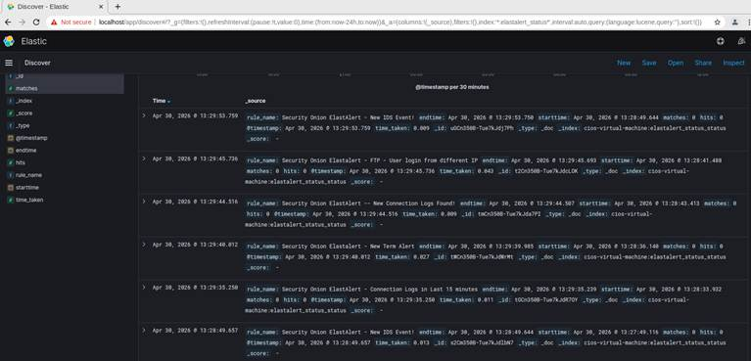
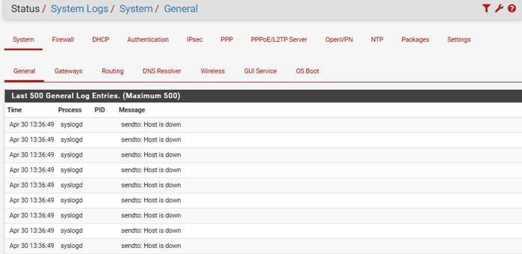
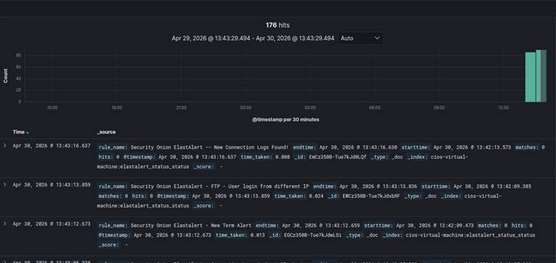
In the alert dashboard, it can be seen that Logstash was sending logs to Kibana because of people potentially scanning through Nmap or netcat to see if the systems were vulnerable. Different alerts such as “user logged different IP” Kibana through different IP was one of the many rules that were set, and it is being successfully logged and sent to the SIEM dashboard. The firewall also seemed to be doing its job, showing “the host is down” through syslogd. Pfsense in the syslogd shows that people were trying to send packets to the system from a Unix or a Linux source and were denied any packets from entering the system itself.

NMAP/BURP/Hping
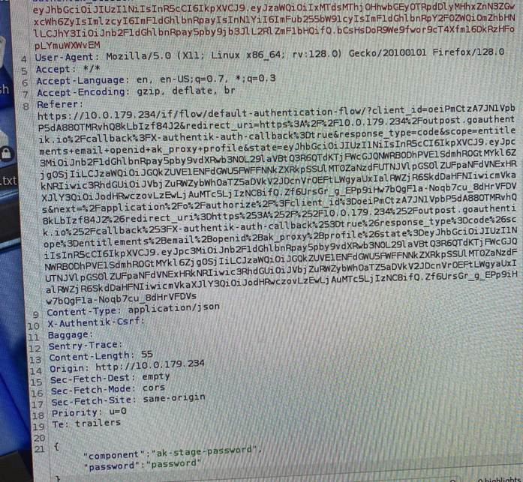
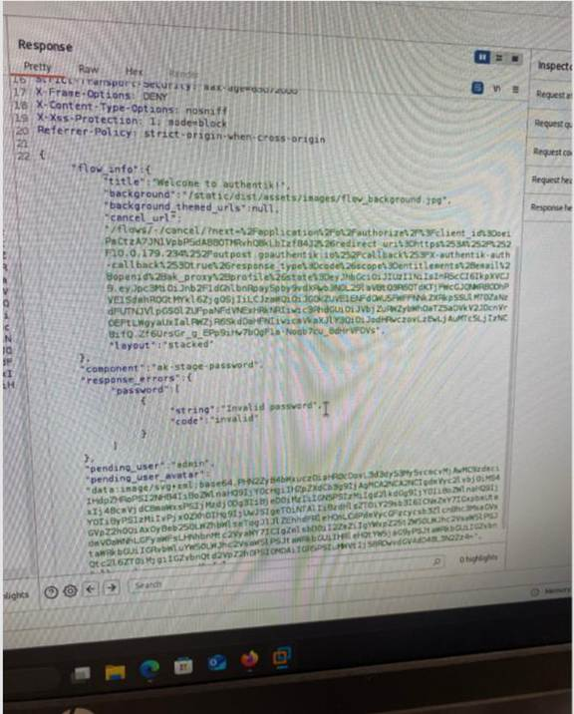
Burp- After scanning with NMAP, the project team discovered that there was a web server over http on IP 10.0.179.234. This was supposed to be the assigned IP range, but it appeared another group decided to use it for their own. It was not known if it was by accident or if they did it to conceal their web server? Anyways, a proxy server interceptor on the localhost was used to reply to send login requests to the server. At first, the project team tried to spam the server with lots of requests at one time, but nothing notable happened. Next, a SQL Injection was attempted. Using lines like “FROM users WHERE ....” doing this multiple times in the password section of the response until something happens. Unfortunately, nothing noteworthy could be done.
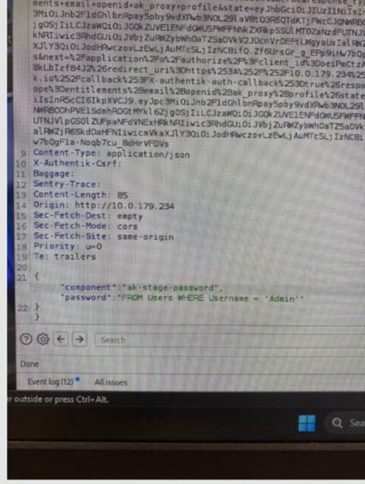
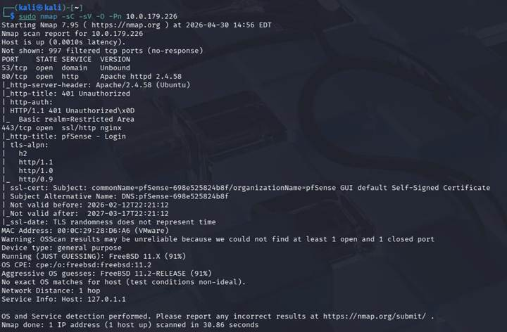
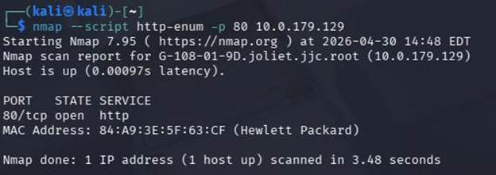
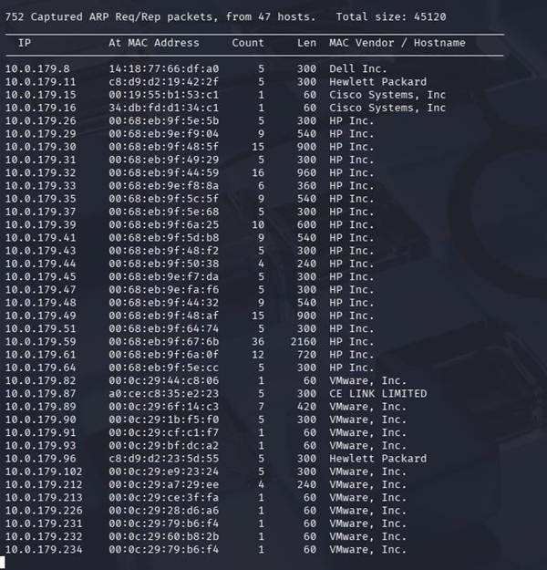
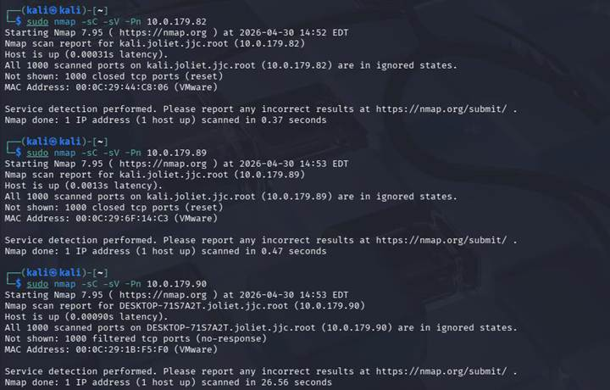
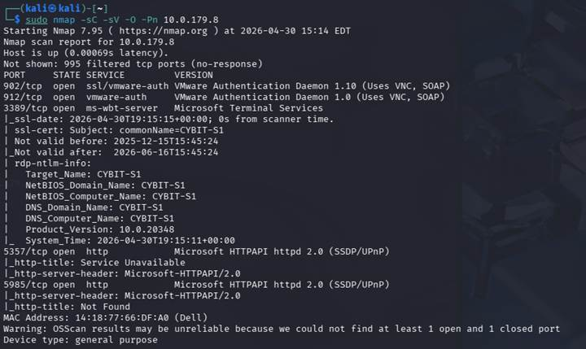
NMAP- This was the most important tool during the vulnerability testing investigation. First, a regular scan was completed to see what hosts were up. Some hosts were found, but it was not clear if it was another student or if it was another machine in the server racks? Anyways, different tools were used to find vulnerabilities. An HTTP enumeration script with Nmap was first used to reveal any types of weak points in the server.
Here were some targets that were enumerated:
10.0.179.87 mohammed.joliet.jjc.root (CE link limited)
10.0.179.96 cios.joliet.jjc.root (VMware)
10.0.179.102 Win11-KK.joliet.jjc.root (HP)
10.0.179.85 wazuh-server.joliet.jjc.root
10.0.179.129 G-108-01-9D.joliet.jjc.root (HP)
Also 10.0.179.234, 10.0.179.225, 10.0.179.223, 10.0.179.226
After enumerating and testing vulnerabilities, the project team decided to try and DOS the webserver on 10.0.179.234 with hping.
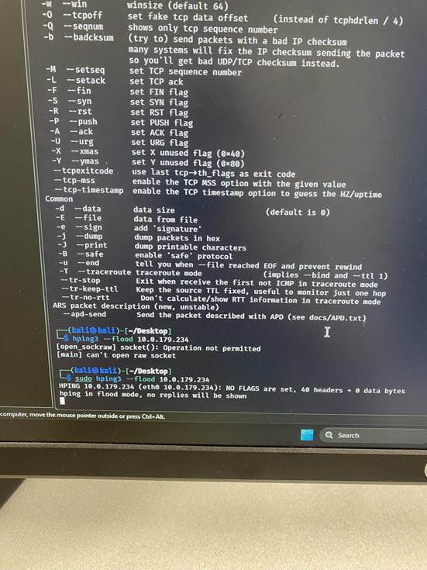
Wrapping up, the project environment was actually compromised by group 4. One of the members used the default login of cios and P@ssw0rd to get into one of the virtual machines and left a message through mousepad!

Overall, the ACME Tutoring Center project demonstrated the planning, implementation, and integration of a multi-layered cybersecurity and network infrastructure designed to support a modern tutoring center environment. Throughout the project, the group implemented firewall security, SIEM monitoring, LDAP and Active Directory services, web authentication, centralized logging, and network segmentation to create a secure and scalable enterprise-style environment. The project reinforced how interconnected cybersecurity systems truly are, as each component depended on communication and coordination with the others in order to function properly. The implementation process also reinforced the importance of teamwork, planning, documentation, and communication, since successful integration depended on each role being properly configured and coordinated with the rest of the environment. Through the implementation process, valuable experience was gained in infrastructure planning, system integration, troubleshooting, vulnerability management, budgeting, and collaborative problem-solving within a real-world cybersecurity setting. Although several technical challenges were encountered during implementation, including communication issues between systems, SIEM log integration difficulties, and authentication synchronization problems, the final environment successfully met the primary project goals and demonstrated a functional security infrastructure for the tutoring center. The project also showed that cybersecurity environments are never completely “finished,” as additional time could further improve system integration, role-based access controls, multi-factor authentication, vulnerability testing, monitoring capabilities, and overall security hardening across the environment. Overall, the project provided a stronger understanding of how enterprise cybersecurity technologies operate together in practice and how secure infrastructure can be designed to support both operational needs and long-term organizational growth.
Works Cited
authentik. (n.d.-a). Forward auth. https://docs.goauthentik.io/add-secure-apps/providers/proxy/forward_auth
authentik. (n.d.-b). LDAP source. https://docs.goauthentik.io/users-sources/sources/protocols/ldap
authentik. (n.d.-c). Welcome to authentik. https://docs.goauthentik.io/
Cybersecurity and Infrastructure Security Agency. (n.d.). Multifactor authentication. https://www.cisa.gov/topics/cybersecurity-best-practices/multifactor-authentication
Kobar, G. (n.d.). Getting started with Elasticsearch. Elastic. https://www.elastic.co/virtual-events/getting-started-elasticsearch
Microsoft. (2025a, May 12). DNS and AD DS. Microsoft Learn. https://learn.microsoft.com/en-us/windows-server/identity/ad-ds/plan/dns-and-ad-ds
Microsoft. (2025b, June 16). Group Policy processing for Windows. Microsoft Learn. https://learn.microsoft.com/en-us/windows-server/identity/ad-ds/manage/group-policy/group-policy-processing
Microsoft. (2025c, September 22). Active Directory security groups. Microsoft Learn. https://learn.microsoft.com/en-us/windows-server/identity/ad-ds/manage/understand-security-groups
National Institute of Standards and Technology. (2025, August 15). Identity & access management. https://www.nist.gov/identity-access-management
Scarfone, K., Hoffman, P., National Institute of Standards and Technology, & Virtual Private Network Consortium. (2009). Guidelines on firewalls and firewall policy. In NIST Special Publication 800-41 (p. 48) [Report]. National Institute of Standards and Technology. https://nvlpubs.nist.gov/nistpubs/legacy/sp/nistspecialpublication800-41r1.pdf
Seget, V. (2025, August 26). Security Onion: Open-source threat hunting & monitoring platform. StarWind Blog. https://www.starwindsoftware.com/blog/security-onion-threat-hunting/
STIG Viewer. (n.d.). https://www.stigviewer.com/stigs/firewall_security_requirements_guide
Top 13 firewall best practices [+ Pitfalls to Avoid]. (n.d.). Palo Alto Networks. https://www.paloaltonetworks.com/cyberpedia/firewall-best-practices

